**Installation Guide**

Ariel University

Hen, Nofar and Yossi

Final project

Appium Automation Testing On Android Devices

December, 2017

# Step By Step

Dependencies:

1. Download appium server (version 1.2.7, if there a newer version choose the newest).

<https://search.maven.org/#search%7Cga%7C1%7Cg%3Aio.appium%20a%3Ajava-client>

1. Download Android Studio

<https://developer.android.com/studio/index.html>

1. A. Get inside the “Enviroment variables” in windows

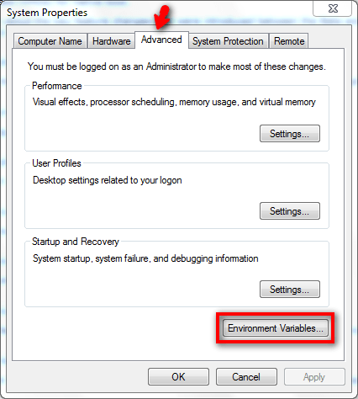

B. press on "environment variables"

1. add the two new variables of "system variables" :

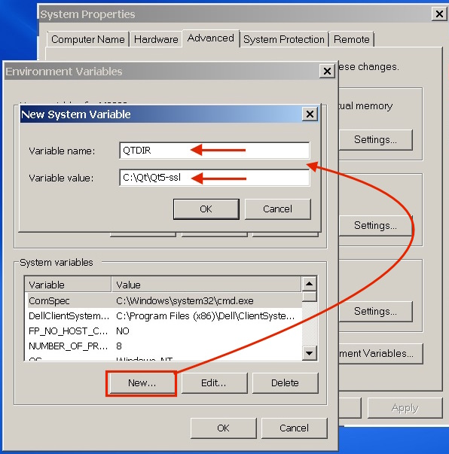

* 1. Variable name: MAVEN_HOME .

Variable value: put the path of "apache-maven-3.5.2-bin" that you download before.

* 1. Variable name: M2_HOME.

Variable value: put the path of "apache-maven-3.5.2-bin" that you download before.

1. add to the path Variable that in "system variables" : MAVEN_HOME , M2_HOME

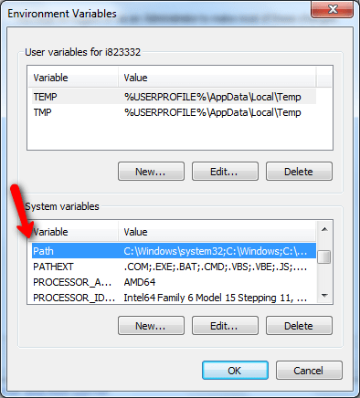

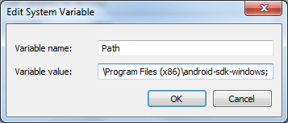

1. add new variable to "User variables for (your computer name) " :

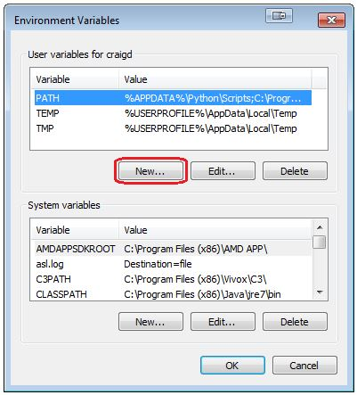

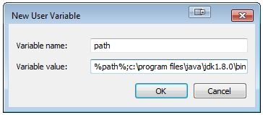

Variable name: pick some name

Variable value: put the path of the adb location

(Usually it's in :

"C:\Users\<**computerName**>\AppData\Local\Android\sdk\platform-tools")

On the android device:

Enable the device for developer options.

**For android 4.1 and up (JB):**

* + - 1. Get into : Settings->About phone
      2. In "Build number" you need to press 7 times until you get the dialog: "You are now 4 steps away from being developer"
      3. Press 4 more times until you get the dialog "You are now a developer!"

4. Get into setting and you will see a new category in name "Developer options"

5. Get into and enable the option of "USB debugging"

|  |  |  |
| --- | --- | --- |
| <https://hwzone.co.il/hwzone.co.il/originals/alon/ADB/33.PNG> | [https://hwzone.co.il/hwzone.co.il/originals/alon/ADB/22.PNG](https://hwzone.co.il/hwzone.co.il/originalsalon/ADB/22.PNG) | <https://hwzone.co.il/hwzone.co.il/originals/alon/ADB/11.PNG> |

**For android 4.0 (ICS):**

* + - 1. Get into : Settings->Developer options

2. Get into and unable the option of "USB debugging"

|  |  |  |
| --- | --- | --- |
| <https://hwzone.co.il/hwzone.co.il/originals/alon/ADB/333.PNG> | [https://hwzone.co.il/hwzone.co.il/originals/alon/ADB/222.PNG](https://hwzone.co.il/hwzone.co.il/originalsalon/ADB/222.PNG) | <https://hwzone.co.il/hwzone.co.il/originals/alon/ADB/111.PNG> |

**For android 2.3 - 4.0 :**

* + - 1. Get into : Settings->Applications->Development

2. Get into and unable the option of "USB debugging"

|  |  |  |
| --- | --- | --- |
| <https://hwzone.co.il/hwzone.co.il/originals/alon/ADB/3.PNG> | [https://hwzone.co.il/hwzone.co.il/originals/alon/ADB/2.PNG](https://hwzone.co.il/hwzone.co.il/originalsalon/ADB/2.PNG) | <https://hwzone.co.il/hwzone.co.il/originals/alon/ADB/1.PNG> |

On your computer:

1. First, go to github with that link:

<https://github.com/hengross/Appium-Project/upload/master>

and download the files :

* 1. “appium project” .
  2. "apache-maven-3.5.2-bin" .
  3. "tcpdump" .

2. Open the folder that all of your android studio projects in.

a. copy the project that you have downloaded from github and paste it in this folder.

b. Go to android studio and click on file-> open -> choose that project to open.

Go to android studio and click on file-> open -> and choose the "appiumProject" project.

To start the project :

1. to start the record Open cmd and run the scripts bellow:

1. adb shell
2. su
3. Tcpdump –i  **interfaceName**  –w storage/emulated/0/**filename**.pcap

(To see what is your interface name you need to run in your cmd the command: "Ifconfig" and look for something like that :

If your on wifi: wlan0

If you'r on phone net: rmnet0)

And Pick some file name that you want

* + - 1. run appium and press the start button.
      2. Start the android project ( press on the green play button ).

## 

## Problems that you can experience:

1. Change in the capabilities the version of your android device
2. Change the browser from “browser” to “chrome” if it doesn't work for your device

# Placeholder image